CCNA: Introduction to Network

**Module 3 – 3.7: Data Access**

**A. Addresses (Địa Chỉ)**

- *The network and data link layers* are responsible for *delivering the data from the source device to the destination device.*

- **Network layer source and destination addresses**: Responsible for delivering the IP packet from the original source to the final destination, which may be on the same network or a remote network.

**- Data link layer source and destination addresses**: Responsible for delivering the data link frame from one network interface card (NIC – Card Giao diện mạng) to another NIC on the same network.

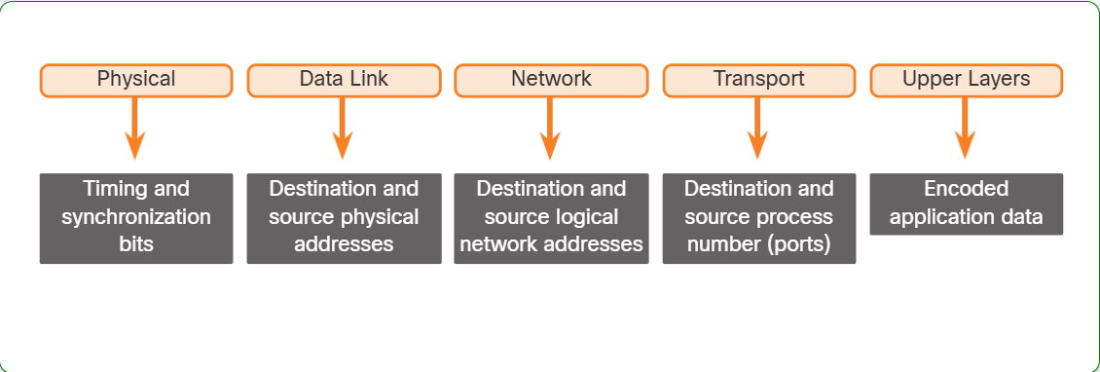

**B. Layer 3 Logical Address**

- Think of an IP address like a postal address. It has two main parts:

+ Network Address (like a city/region): This is the common part shared by everyone in the same area. It tells the mail carrier *where* to go generally.

+ Host Address (like a house number): This is the unique part that identifies a specific house *within* that city/region. It tells the mail carrier *exactly* which house to deliver to.

- Example (IPv4):

- Let's say your IP address is 192.168.1.110.

+ Network Address (192.168.1): This is like the city/region. All devices on your local network (e.g., your computer, phone, printer) will share this same network address. It tells routers to send the packet to *your* general network.

+ Host Address (110): This is like your house number. It's unique to your specific device on the network. It tells the last router (or switch) on your network *exactly* which device to deliver the packet to.

- Example Scenario:

Imagine you're sending a message from your computer (192.168.1.110) to a web server (172.16.1.99).

+ Your computer creates an IP packet with your IP address as the *Source IP* and the web server's IP address as the *Destination IP*.

+ Routers along the way use the *Network Address* part of the *Destination IP* (172.16.1) to guide the packet closer to the web server's network. They don't need to know the exact host address yet; they just need to get to the right "city/region."

+ The last router on the web server's network uses the *Host Address* (99) to deliver the packet to the correct web server.

**C. Devices on the Same Network**

In this example we have a client computer, PC1, communicating with an FTP server on the same IP network.

+ Source IPv4 address - The IPv4 address of the sending device, the client computer PC1: 192.168.1.110.

+ Destination IPv4 address - The IPv4 address of the receiving device, FTP server: 192.168.1.9.

**D. Role of the Data Link Layer Addresses - Same IP Network**

When the sender and receiver of the IP packet are on the same network, the data link frame is sent directly to the receiving device.